GDE405 Readings & Assignments: Week 6

Week 6 Reading
Complete the following reading early in the week:
- The online lectures for Week 6.
- The following pages from the book, Dynamic Figure Drawing by Burne Hogarth:
  - Chapter 4, pp. 104–119
  - Chapter 5, pp. 134–149
Week 6 Assignments Overview
Assignment Summary: Week 6 | Due
Assignment 1: Discussion Questions | Tuesday, November 11, 2008
Assignment 2: Applying Perspective to Figure Drawing | Tuesday, November 11, 2008
Assignment 3: Advanced Figure Drawing Session/Final Project | Wednesday, November 12, 2008
Remember that all assignment details can be found on the assignment pages located throughout the week. Go to those specific pages for direction on how to complete each individual assignment.

Week 6 Overview

Learning Outcomes
- Learn foreshortening and perspective techniques.
- Learn to depict drapery.
- Learn about color theory.
- See an improvement in their ability to draw the human figure regardless of position.
- Become more aware of page appearance and composition.
- Be more able to assess the effectiveness of a human image and more able to verbalize their reasoning.

Foreshortening and Perspective
In this week, the depiction of more advanced figure drawing techniques and elements will be explored. Foreshortening, perspective, depiction of drapery, and color will be discussed and exercises to achieve successful drawings with these elements will be presented.
A substantive knowledge of perspective and foreshortening is important in many areas of art. Landscapes, interiors, and figure drawing each require an in-depth study of the principles of foreshortening and perspective in order to truly convey each form of subject matter in space. Representing the three-dimensionality of the figure on a two dimensional surface can be difficult depending on the intricacies of the pose and number of figures in the composition. The poses that most often require the manipulation of perspective are the seated and the reclining poses. Standing poses are easier to draw since the views are relatively proportional and relate to what the eye sees. The figure becomes more difficult when forms are overlapping, condensed, or stacked in space.
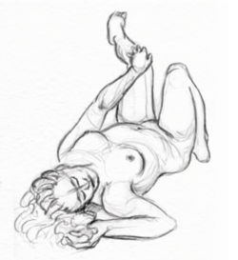
Following are several examples of poses that require applying perspective of the figure in space.
- Lying down/head first. In this view the model's head would be larger than usually drawn since it is the closest thing to you. Plot lines along the diagonal to determine where the rest of the body parts lie. The feet will proportionally be the smallest body part since they are furthest away.

- Seated, one knee facing (see example below). This pose requires the left leg and arm to be drawn slightly larger than the right leg and arm since they are receding in space. In order to create this pose, 1/4 of the body and the centerline should be drawn to convey the left side of the body while the other 3/4 of the drawing should convey the right side. 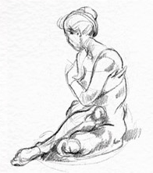
- This pose requires the head, shoulders and arms to be larger in proportion to the legs and feet.
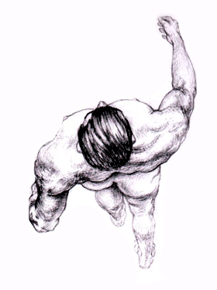

Drapery
Fabric and Drapery are integral elements in many types of figure drawing. As in a classic pose, the model may be resting on or have a drape around a portion of his/her body. Or you may be working with a model who is clothed. Therefore, any study of figure drawing should include an overview of depicting drapery as it relates to the human form.
When rendering fabric or drapery, consider the following:
Texture
What is the weight of the fabric? Is it a heavy denim or leather? Is it a silky scarf or dress that appears to have no structure whatsoever? This will greatly influence your approach to and materials used to depict the fabric.
Structure
As in any object that is depicted visually, the underlying structure of the fabric or drapery must be understood and depicted properly before any shading or detail can be conveyed. Look at the entire shape of the form and see the overall form first before going into the smaller forms that lie within. One helpful exercise to understand the structure of fabric is to crumple up several pieces of paper (blank white) and staple them together in an abstract yet structured shape. Crinkle certain portions and leave others with a smoother surface. This helps to understand that regardless of how light or sheer the fabric may seem, the underlying structure must always be depicted first.
Geometric Shapes
Once the structure is in place, the smaller shapes within the fabric can start to be represented by geometric shapes such as modified triangles, rectangles, squares, etc. Do not use softened or curved lines at this point, no matter how weightless the fabric may seem. Try to keep the structure of the fabric.
Folds/Creases
When representing folds or creases in a garment, remember that they usually start from a point and then fan out from that densest point of origin. Straight folds usually have a cone shape and are darkest at the point of insertion and then get lighter. Notice where the light is falling to help determine how the folds are lit.
Light/Dark
When drawing drapery try to stay away from hard edges or lines. Subtle shading is the best approach, with hard lines only for a dark shadow, accent, or a particularly sharp fold or shadow.
The Figure Underneath
Drawing the draped or clothed figure is always dependent upon the pose underneath the garment or drape. When drawing a clothed figure, draw the stick figure first and add the clothes on top with the folds added last. Build the figure from the inside out.
Explore: Check out fabric university! - http://www.fabriclink.com/University.html

Color and the Figure
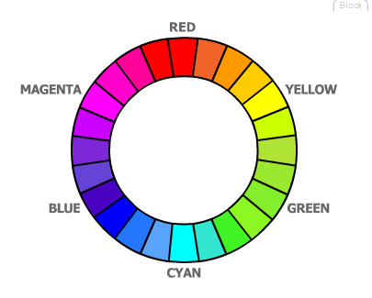
Adding color to your figure drawings requires more depth than we can go into in just two sessions. However, there are ways you can start to incorporate color into your drawings without overwhelming yourself with the new media and color choices available. If you haven't tried or had much experience with painting, it is not recommended that you start using color paint media in your figure work until gaining confidence with several of the techniques and media outlined below. Here is a review of some basic color concepts.

The Color Wheel
A 12-hue color wheel is the color system used by most artists. You can buy a color wheel in most art supply stores. However, it is best that you take some time and mix your own to gain a better understanding of what happens when certain colors are mixed together. It is important to remember the terms of the color system; hence we will review some basic color theory.

Primary Colors
Red, yellow, and blue are the three primary colors of the wheel. That means they are colors that cannot be mixed by any color combination. Therefore, it is important that at the very least you have these three colors, plus black and white, in your painting kit so you can mix the other colors on your color wheel for any palette combination. The triangle they form on the color wheel is called the primary color triad.
Secondary Colors
When primary colors are mixed together they form the secondary color triad. Orange, violet, and green are the secondary colors.
- Red + Blue = Violet.
- Red + Yellow = Orange.
- Yellow + Blue = Green.

Tertiary Colors
When a primary and secondary color are mixed together they form the tertiary color triad or intermediate colors. They are easy to remember as they have compound names.
- Yellow + Green = Yellow-green.
- Red + Orange = Red-orange.
- Red + Violet = Red-violet.
- Blue + Violet = Blue-violet.
- Blue + Green = Blue-green.
- Yellow + Green = Yellow-green.
Complementary Colors
Complementary colors are those that lie opposite from each other on the color wheel. When complementary colors are mixed, they produce neutralized and beautiful versions of their original colors and are often good colors to use together. When continually mixed together they will form an off-neutral gray. The three main complementary color mixtures are:
- Yellow/Violet.
- Blue/Orange.
- Red/Green.
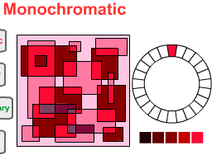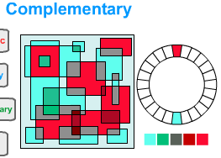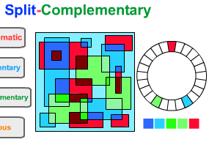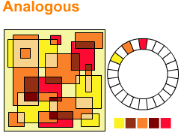

Analogous Colors
Analogous colors are the three, four, or five colors that are adjacent on the color wheel. The most successful analogous palette is one that has at least one primary color as a common element in each.
- Yellow, yellow-orange, orange, yellow-green, green.
- Red, red-orange, orange, red-violet, violet.
- Blue, blue-violet, violet, blue-green, green.
Black and White with the Color Wheel
When white is added to one of the twelve colors on the color wheel, it becomes a tint of that color or a pastel version. When a color is lowered in its value by either its complementary color or with black, it is called a shade of the color. Eventually, we will try to reduce the amount of black and white we'll be using. If you want to darken your local color try the color's compliment before using black. If you want to lighten a color's value, try adding an analogous color that is brighter on the spectrum rather than white. If the combinations don't work, then use your black and white.

Color and the Figure II
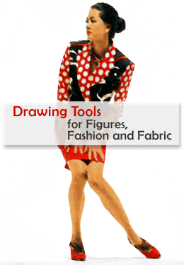
Color Drawing and Painting Materials and Palettes for Figure Drawing
Conté Crayon
Conté crayon is an excellent bridge from charcoal/graphite figure drawings to color. Since it only comes in earth tones (browns, rusts, burnt sienna, etc.) it is a centuries-old tool used for depicting flesh tones. Use it as a middle tone and add darks with charcoal and lights with a white conté stick. Look up master's drawings to copy and to study how this medium is used.
Color pencil/markers/pens
Color pencil/markers/pens are excellent tools to gain confidence with the graphic application of color. Because they are best used as a layered tool, you can blend several colors together while having some of the underlying layer of color show through. However, all of these tools can often lead the user to apply them with a more rigid and tighter approach than other color drawing tools. Use these tools in quick sketches with broad, bold strokes rather than in a tight, rigid, and controlled manner.
Pastel
Pastel is another bridge media from drawing with charcoal and graphite to working with color. Because the approach and mark making is similar to drawing, you can build your confidence slowly and add colors as you are more comfortable. Also start by using chalk or soft pastels rather than oil based pastels. The soft pastels are excellent for blending and are easier to use with other drawing media. Oil based pastels are waxier and are meant to be used in layers and for a textured effect.
Start building your color palette by slowly adding the following colors:
- Naples Yellow for warm highlights
- A peachy tone for Caucasian flesh color or rust/brown for Indian, African American, and other similar ethnic types
- Soft lilac for cool lights
- Warm red for warm darks
- Viridian Green, Pthalo Blue or Dioxaxine Purple for dark colors
- Mars Black
- Titanium White

Color Drawing and Painting Materials and Palettes for Figure Drawing
Painting can certainly be approached using some of the same building processes as drawing with color tools. Watercolor or water-based oil paints can be used and watered down until you become comfortable with using a brush rather than a drawing tool. Illustration boards or canvas boards are cheaper surfaces to use when you begin painting. Look for the same family of colors as in the pastels, and use lots of water to keep the colors wet and less vivid to start. Painting can become overwhelming when there are too many choices of brushes and color. Use the following palettes to start building your experience with painting the figure in color:
- Colorizing the figure is the process of using one color plus black and white. This can be an excellent beginning exercise. Use the color for your mid-range and try to have it be represented throughout your drawing and not just in patches.
- Complimentary palette.
- Complementary colors are those that lie opposite from each other on the color wheel. When complementary colors are mixed they produce neutralized and beautiful versions of their original colors and are often good colors to use together. When continually mixed together they will form an off-neutral gray.
- The three primary complementary color mixtures are:
  - Orange/Blue
  - Yellow/Purple
  - Green/Red plus your black and white
- Analagous palette are three or four colors next to each other on the color wheel, such as yellow-green, yellow, yellow orange, orange.

Course Summary
Congratulations! You have completed the last week of the Dynamic Figure Drawing course. By taking your basic knowledge of figure drawing and anatomy, this course has brought you to the next, more advanced level, of figure drawing. Dynamic figure drawing is the process of developing more of your personal style, broadening your uses and approach to the media, and creating your own unique works of art. Continue to draw dynamically by revisiting these exercises with different media, compositions, and approaches. Draw a range of quick sketches in a sketchbook from life, memory, and photo sources. Use these studies to create finished works.

Assignment 1: Discussion Questions
By Tuesday, November 11, 2008, respond to the discussion questions assigned to you by the facilitator. Submit your responses to the appropriate topic in this Discussion Area. Start reviewing and responding to your classmates as early in the week as possible. You can ask questions or respond generally to the overall experience. Ensure to be honest, clear, and concise. Always use constructive language, even in criticism, to work towards the goal of positive progress.
Grading Criteria: | Maximum Points
Comments are clear and concise. | 4
Participates in the discussion with concise and clear comments. | 4
Student uses terminology and relates concepts introduced in course studies throughout discussion contributions. | 4
Student brings additional questions and observations into the discussion. | 4
Total: | 16
For assistance with any problems you may have when completing this assignment—OR—to offer your assistance to classmates, please use the Problems and Solutions Discussion area located through the left side navigation link.
Discussion Question 1
Using Color in Drawing
What is your experience using color in either drawing or painting? What do you find are your strengths? Weaknesses?
Using a Color Wheel
How comfortable do you feel while using the color wheel? Or would you prefer to mix your own colors. How does that help you gain a better understanding of the color combinations?
Discussion Question 3
Tools for Drawing
During this course, you have used various tools for drawings. (Chalks, pens, pencils, markers, crayons etc.) Share your observations about what kind of drawings/effects can be best created particular types of tools
Discussion Question 4
Learning Experiences
Share your experiences of learning during this course. What are the most interesting techniques that you have learnt and would like to practice and improve upon?
Respond to discussion question one and then to two other student's answers.

Assignment 2: Applying Perspective to Figure Drawing
Create one drawing using any of the techniques outlined in the lecture for: foreshortening, perspective, and the figure. Scan or shoot the drawings with a digital camera and save the image as a jpeg file. Submit the drawings to this Discussion Area, by Tuesday, November 11, 2008.
Review and critique the work of at least two other students. Post your comments by responding to the appropriate thread. You can ask questions or respond generally to the overall experience. Always be honest, clear, and concise, using constructive language, even in criticism, to work toward the goal of positive progress.
Grading Criteria: | Maximum Points
Use of principles taught in the lectures. | 4
Ability to convey each of the three poses accurately and dynamically. | 4
Assignment submitted as scheduled. | 4
Participated in the discussion with concise and clear comments. | 4
Total: | 16
For assistance with any problems you may have when completing this assignment—OR—to offer your assistance to classmates, please use the Problems and Solutions Discussion area located through the left side navigation link.
This is the key to believable figures.
Lying, seated, topdown.

Assignment 3: Advanced Figure Drawing Session/Final Project
By Wednesday, November 12, 2008, submit the final work from your rough draft in W5: Assignment 5 to this Discussion area. Scan or shoot the drawings with a digital camera and save the image as a jpeg file.
This project should incorporate and apply as many of the techniques and approaches you've learned in class as possible. These include:
- Accuracy in depicting the surface anatomy of the figure(s).
- Depiction of tension between the balance and active/passive sides of the figure(s).
- Incorporation of new media (charcoal, graphite, pen/ink, markers, pastels, water-based paint, etc.).
- Ability to render a final figure drawing.
- Awareness of the entire page and composition as a whole rather than a sketch or study.
- Resolution of the background.
- Resolution and demonstration of perspective/foreshortening.
Project Outline
Final drawings of your four gesture drawings from week 5.
- Using your model, do at least four gesture studies of different poses in a particular setting. Do not just have the model alone in your composition. Set the model up in an environment with a still life, outside, etc. In these drawings, play with space, composition, materials, etc., to decide the materials and approach to your final piece.
- Produce your final piece using the media of your choice.
- This project should take you about five hours to complete.
Review and critique the work of at least two other students. Post your comments by responding to the appropriate thread. You can ask questions or respond generally to the overall experience. Always be honest, clear, and concise, using constructive language, even in criticism, to work toward the goal of positive progress.
Grading Criteria: | Maximum Points
Student's progress throughout the course. | 4
Ability to incorporate many of the approaches and techniques covered in the course. | 4
Development of student's own personal style and approach to dynamic figure drawing. | 4
Project submission on time. | 4
Participation and constructive feedback in critique. | 4
Total: | 20
For assistance with any problems you may have when completing this assignment—OR—to offer your assistance to classmates, please use the Problems and Solutions Discussion area located through the left side navigation link.
This should show what you have learned! Do well.

